IT24100571

Paranavithana.D.S.

**Q1**

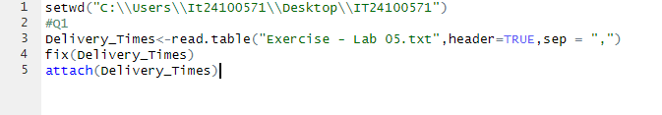

Q2

Q3



Q4

